**Problem Statement:** Database Design for Healthcare Records

1. Entity Relationship Diagram

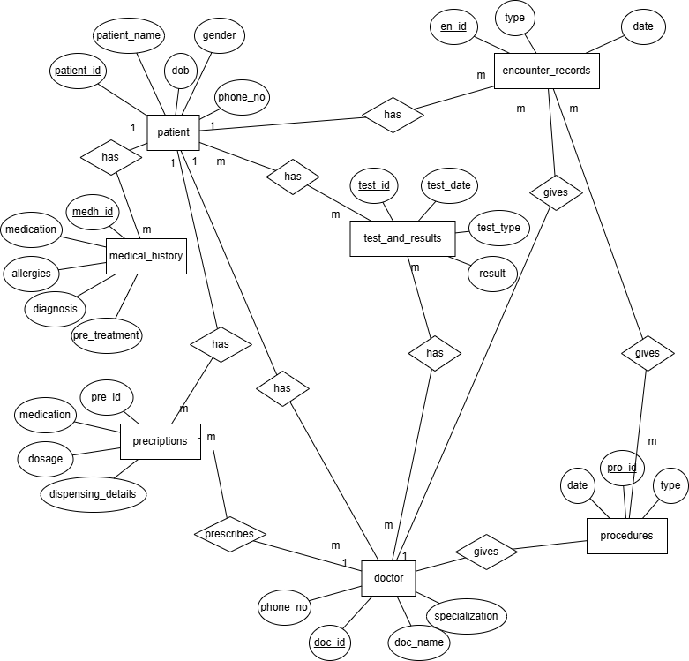

1. Database structure and tables:

mysql> desc patient;

+--------------+-------------+------+-----+---------+-------+

| Field | Type | Null | Key | Default | Extra |

+--------------+-------------+------+-----+---------+-------+

| patient_id | int | NO | PRI | NULL | |

| patient_name | varchar(50) | YES | | NULL | |

| gender | varchar(10) | YES | | NULL | |

| dob | date | YES | | NULL | |

| phone_no | bigint | YES | | NULL | |

+--------------+-------------+------+-----+---------+-------+

5 rows in set (0.00 sec)

mysql> select * from patient;

+------------+---------------+--------+------------+------------+

| patient_id | patient_name | gender | dob | phone_no |

+------------+---------------+--------+------------+------------+

| 1 | Aarav Mehta | Male | 1990-05-15 | 9876543210 |

| 2 | Ishita Sharma | Female | 1988-11-23 | 9123456789 |

| 3 | Raj Verma | Male | 1975-03-10 | 9988776655 |

| 4 | Sneha Reddy | Female | 1995-07-19 | 9012345678 |

| 5 | Karan Patel | Male | 1982-12-30 | 8765432109 |

| 6 | Diya Nair | Female | 1993-09-25 | 9112233445 |

| 7 | Arjun Singh | Male | 1980-01-05 | 9090909090 |

| 8 | Priya Desai | Female | 1991-04-08 | 9876512345 |

| 9 | Rohan Joshi | Male | 1985-06-12 | 9321654987 |

| 10 | Neha Kapoor | Female | 1997-02-20 | 9123459876 |

+------------+---------------+--------+------------+------------+

10 rows in set (0.00 sec)

mysql> desc doctor;

+----------------+--------------+------+-----+---------+-------+

| Field | Type | Null | Key | Default | Extra |

+----------------+--------------+------+-----+---------+-------+

| doc_id | int | NO | PRI | NULL | |

| doc_name | varchar(50) | YES | | NULL | |

| phone_no | bigint | YES | | NULL | |

| specialization | varchar(100) | YES | | NULL | |

+----------------+--------------+------+-----+---------+-------+

4 rows in set (0.00 sec)

mysql> select * from doctor;

+--------+-------------------+------------+-------------------+

| doc_id | doc_name | phone_no | specialization |

+--------+-------------------+------------+-------------------+

| 1 | Dr. Ravi Kumar | 9988771122 | Cardiologist |

| 2 | Dr. Anjali Menon | 9876544433 | Dermatologist |

| 3 | Dr. Suresh Gupta | 9345612345 | Orthopedic |

| 4 | Dr. Meena Iyer | 9765432198 | Pediatrician |

| 5 | Dr. Ajay Singh | 9988776655 | Neurologist |

| 6 | Dr. Lakshmi Rao | 9456123789 | ENT Specialist |

| 7 | Dr. Vishal Thakur | 9654321789 | General Physician |

| 8 | Dr. Reema Das | 9345678901 | Gynecologist |

| 9 | Dr. Nikhil Shah | 9988665544 | Pulmonologist |

| 10 | Dr. Swati Pandey | 9123456701 | Psychiatrist |

+--------+-------------------+------------+-------------------+

10 rows in set (0.00 sec)

mysql> desc procedures;

+------------+--------------+------+-----+---------+-------+

| Field | Type | Null | Key | Default | Extra |

+------------+--------------+------+-----+---------+-------+

| pro_id | int | NO | PRI | NULL | |

| patient_id | int | YES | MUL | NULL | |

| type | varchar(100) | YES | | NULL | |

| date | date | YES | | NULL | |

| doc_id | int | YES | MUL | NULL | |

+------------+--------------+------+-----+---------+-------+

5 rows in set (0.00 sec)

mysql> select * from procedures;

+--------+------------+--------------------------+------------+--------+

| pro_id | patient_id | type | date | doc_id |

+--------+------------+--------------------------+------------+--------+

| 1 | 1 | ECG | 2023-01-10 | 1 |

| 2 | 2 | Skin Biopsy | 2023-02-15 | 2 |

| 3 | 3 | Knee Surgery | 2022-12-05 | 3 |

| 4 | 4 | Tonsil Removal | 2023-03-12 | 6 |

| 5 | 5 | Brain MRI | 2023-04-18 | 5 |

| 6 | 6 | Ear Cleaning | 2023-05-22 | 6 |

| 7 | 7 | Annual Checkup | 2023-06-10 | 7 |

| 8 | 8 | Pelvic Ultrasound | 2023-07-08 | 8 |

| 9 | 9 | Chest X-ray | 2023-08-02 | 9 |

| 10 | 10 | Mental Health Evaluation | 2023-09-25 | 10 |

+--------+------------+--------------------------+------------+--------+

10 rows in set (0.00 sec)

mysql> desc test_and_results;

+------------+--------------+------+-----+---------+-------+

| Field | Type | Null | Key | Default | Extra |

+------------+--------------+------+-----+---------+-------+

| test_id | int | NO | PRI | NULL | |

| patient_id | int | YES | MUL | NULL | |

| test_type | varchar(100) | YES | | NULL | |

| test_date | date | YES | | NULL | |

| result | varchar(255) | YES | | NULL | |

| doc_id | int | YES | MUL | NULL | |

+------------+--------------+------+-----+---------+-------+

6 rows in set (0.00 sec)

mysql> select * from test_and_results;

+---------+------------+----------------+------------+------------------+--------+

| test_id | patient_id | test_type | test_date | result | doc_id |

+---------+------------+----------------+------------+------------------+--------+

| 1 | 1 | Blood Pressure | 2023-01-10 | 140/90 | 1 |

| 2 | 2 | Allergy Test | 2023-02-16 | Positive | 2 |

| 3 | 3 | HbA1c | 2022-12-10 | 7.5% | 3 |

| 4 | 4 | Throat Swab | 2023-03-13 | Bacterial | 4 |

| 5 | 5 | Lipid Profile | 2023-04-19 | High LDL | 5 |

| 6 | 6 | Joint X-ray | 2023-05-23 | Normal | 6 |

| 7 | 7 | CBC | 2023-06-11 | Within range | 7 |

| 8 | 8 | TSH | 2023-07-09 | Elevated | 8 |

| 9 | 9 | Spirometry | 2023-08-03 | Mild obstruction | 9 |

| 10 | 10 | Psych Eval | 2023-09-26 | Mild anxiety | 10 |

+---------+------------+----------------+------------+------------------+--------+

10 rows in set (0.00 sec)

mysql> desc prescriptions;

+--------------------+--------------+------+-----+---------+-------+

| Field | Type | Null | Key | Default | Extra |

+--------------------+--------------+------+-----+---------+-------+

| pre_id | int | NO | PRI | NULL | |

| patient_id | int | YES | MUL | NULL | |

| medication | varchar(255) | YES | | NULL | |

| dosage | varchar(50) | YES | | NULL | |

| dispensing_details | varchar(255) | YES | | NULL | |

| doc_id | int | YES | MUL | NULL | |

+--------------------+--------------+------+-----+---------+-------+

6 rows in set (0.00 sec)

mysql> select * from prescriptions;

+--------+------------+---------------+---------+--------------------+--------+

| pre_id | patient_id | medication | dosage | dispensing_details | doc_id |

+--------+------------+---------------+---------+--------------------+--------+

| 1 | 1 | Amlodipine | 5mg | Once daily | 1 |

| 2 | 2 | Loratadine | 10mg | At night | 2 |

| 3 | 3 | Glibenclamide | 5mg | Twice daily | 3 |

| 4 | 4 | Azithromycin | 500mg | Three days | 4 |

| 5 | 5 | Simvastatin | 20mg | Bedtime | 5 |

| 6 | 6 | Naproxen | 250mg | After meals | 6 |

| 7 | 7 | Calpol | 500mg | As needed | 7 |

| 8 | 8 | Eltroxin | 100mcg | Empty stomach | 8 |

| 9 | 9 | Asthalin | Inhaler | Before activity | 9 |

| 10 | 10 | Escitalopram | 10mg | Daily morning | 10 |

+--------+------------+---------------+---------+--------------------+--------+

10 rows in set (0.00 sec)

mysql> desc medical_history;

+--------------------+--------------+------+-----+---------+-------+

| Field | Type | Null | Key | Default | Extra |

+--------------------+--------------+------+-----+---------+-------+

| medh_id | int | NO | PRI | NULL | |

| patient_id | int | YES | MUL | NULL | |

| medication | varchar(255) | YES | | NULL | |

| allergies | varchar(255) | YES | | NULL | |

| diagnosis | varchar(255) | YES | | NULL | |

| previous_treatment | varchar(255) | YES | | NULL | |

+--------------------+--------------+------+-----+---------+-------+

6 rows in set (0.00 sec)

mysql> select * from medical_history;

+---------+------------+---------------+------------+-------------------+--------------------+

| medh_id | patient_id | medication | allergies | diagnosis | previous_treatment |

+---------+------------+---------------+------------+-------------------+--------------------+

| 1 | 1 | Aspirin | None | Hypertension | Lifestyle changes |

| 2 | 2 | Cetirizine | Dust | Allergic Rhinitis | Antihistamines |

| 3 | 3 | Metformin | None | Diabetes | Insulin therapy |

| 4 | 4 | Amoxicillin | Penicillin | Throat infection | Home remedies |

| 5 | 5 | Atorvastatin | None | High cholesterol | Diet control |

| 6 | 6 | Ibuprofen | NSAIDs | Joint pain | Physiotherapy |

| 7 | 7 | Paracetamol | None | Fever | Hydration |

| 8 | 8 | Levothyroxine | None | Thyroid disorder | Tablet daily |

| 9 | 9 | Salbutamol | Pollen | Asthma | Inhaler use |

| 10 | 10 | Sertraline | None | Anxiety | Talk therapy |

+---------+------------+---------------+------------+-------------------+--------------------+

mysql> desc encounter_records;

+------------+-------------+------+-----+---------+-------+

| Field | Type | Null | Key | Default | Extra |

+------------+-------------+------+-----+---------+-------+

| en_id | int | NO | PRI | NULL | |

| patient_id | int | YES | MUL | NULL | |

| doc_id | int | YES | MUL | NULL | |

| type | varchar(50) | YES | | NULL | |

| date | date | YES | | NULL | |

+------------+-------------+------+-----+---------+-------+

5 rows in set (0.00 sec)

mysql> select * from encounter_records;

+-------+------------+--------+---------------+------------+

| en_id | patient_id | doc_id | type | date |

+-------+------------+--------+---------------+------------+

| 1 | 1 | 1 | Outpatient | 2023-01-10 |

| 2 | 2 | 2 | Outpatient | 2023-02-15 |

| 3 | 3 | 3 | Emergency | 2022-12-05 |

| 4 | 4 | 4 | Outpatient | 2023-03-12 |

| 5 | 5 | 5 | Consultation | 2023-04-18 |

| 6 | 6 | 6 | Outpatient | 2023-05-22 |

| 7 | 7 | 7 | General Check | 2023-06-10 |

| 8 | 8 | 8 | Outpatient | 2023-07-08 |

| 9 | 9 | 9 | Emergency | 2023-08-02 |

| 10 | 10 | 10 | Psych Consult | 2023-09-25 |

+-------+------------+--------+---------------+------------+